

**Backup Automation Daemon**

**Software Requirement Specification (SRS) Document**

**Sprint 1 Implementation**

**Project Timeline: 21.10.2022 to 28.10.2022**

**INDEX**

1. Introduction

1.1 Purpose ------------------------------- 4

1.2 Intended audience ------------------------------- 4

1.3 Intended use ------------------------------- 4

1.4 Scope ------------------------------- 4

2. Overall description ------------------------------- 4

2.1 Assumptions and dependency ------------------------------- 4

3. System feature and requirements ------------------------------- 4

3.1 Functionality ------------------------------- 4

3.1.1 CAPG89FR01-> Daemon implementation ------------------------------- 4

3.1.2 CAPG89FR02-> User-defined back-up time -------------------------------- 4

3.1.3 CAPG89FR03-> Success/failure -------------------------------- 5

3.1.4 CAPG89FR04-> Notification -------------------------------- 5

3.2 System requirement --------------------------------5

3.2.1 Tools to be used ------------------------------- 5

3.3 System feature -------------------------------5

4. Data Flow Diagram

4.1 DFD level 0 ------------------------------- 6

4.2 DFD level 1 ------------------------------- 7

### **Introduction: -**

The introduction of the software requirement specification provides an overview of the entire software. The entire SRS with overview description purpose, scope, tools used and basic description.

The aim of this document is to gather, analyze and give an in-depth insight into the complete Backup Automation Daemon of files and directories by defining the problem statement in detail.

The detailed requirements of the Backup Automation Daemon are provided in this document.

**1.1** **Purpose**: **-**The purpose of this document is to show the requirements for the Backup Automation Daemon, which creates a backup of all the files and directories in the targeted remote location to a particular at the suitable time without losing them.

**1.2** **Intended Audience: -**This document is intended to be read by Client.

**1.3** **Intended Use: -**

* Development Team
* Maintenance Team
* Servers and networking devices
* Clients

Since this a general-Purpose Software any one can access it.

**1.4** **Scope: -**

This project aims to create the development of Backup Automation Daemon using C and Linux. This system consists of an application which will serve as a platform for users to back up their files and directories automatically at the desired time. The scope of the backup policy will typically set forth what, when, and how of the backup process.

This system aims at backing-up all the data for the user to a desired location at a particular time and notifying the user of the success/failure of the back-up process. It will also display the user about the volume management like remaining disk space.

**2. Overall Description: -**

Automatic backup is primarily enabled through backup software that automates the entire backup process. It means organizations can back up files, folders and systems without any human intervention. Essentially, automated backups simplify backup procedures to drive speedy recoveries. Unlike manual backups, automatic backups **don't require you to remember to back up your data every time**. Just set up a schedule and the system will take care of the rest. Automatic backup can also be easily used by employees who aren't tech-savvy.

Automated backup systems (ABS) gather, compress, encrypt and transfer data automatically from a computer system to a backup drive. An Automated backup systems (ABS) comes with an automated backup mechanism that schedules backups. It also includes a simple user interface to ensure daily automatic backups occur without further input from the end user. 

**2.1 Assumptions and Dependency: -**

* System should have any flavor of Linux installed.
* System should have either 4GB or more RAM.
* The service is used preferably on a desktop or laptop.

**3.System Features and Requirements: -**

**3.1 Functionality: -**

**3.1.1 CAPG89FR01->** **Daemon implementation:** A daemon is a service process that runs in the background and supervises the system or provides functionality to other processes. Two daemon processes to run on two machines or a single machine.

**3.1.2 CAPG89FR02-> User-defined back-up time:** The user will define the time for the backup process to be implemented automatically every day when she/he logs into the system.

**3.1.3 CAPG89FR03->** **Success/failure**: After the completion of backup process, the system will write a message to logged in user about the success/failure of the process.

**3.1.4 CAPG89FR04-> Notification:** The system willreport use of files and volume on remote(self) systems, i.e., the remaining disk space left after the back-up.

**3.2 System Requirements: -**

### **3.2.1. Tools to be used:**

* Valgrind
* C Unit test
* Make
* Gdb tool
* C File and Dirent Handling

### **3.3 System Features: -**

### Supportability:The system is easy to use.

* Design Constraints: The system is built using only C language.
* Usability:The Back-up Automation Daemon system helps the user to create backups automatically without the human interventions.
* Reliability & Availability**:** The system is available to user 24/7 that is whenever the user would like to use the system, they can use it up to its functionalities.

### Performance: The performance will not be affected because Daemon is a background process and as it is in the sleep mode, it will not use any CPU cycles.

**4. Data Flow Diagram:**

**4.1 DFD Level 0 -**

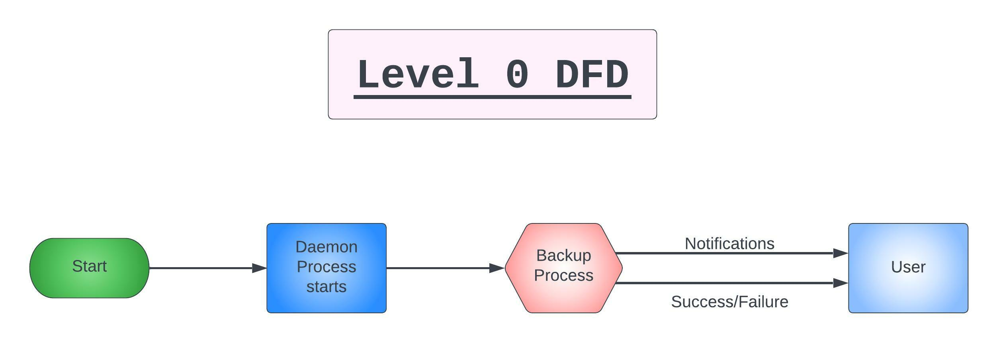

**4.1 DFD Level 1 -**

